**Project Design Phase-II**

**Technology Stack (Architecture & Stack)**

|  |  |
| --- | --- |
| Date | 29 October 2022 |
| Team ID | PNT2022TMID43481 |
| Project Name | Real- Time River water Quality monitoring and control system |
| Maximum Marks | 4 Marks |

Summary

This code pattern explains how to build an IOT based river water monitoring and controlling system with some predefined values.

Flow

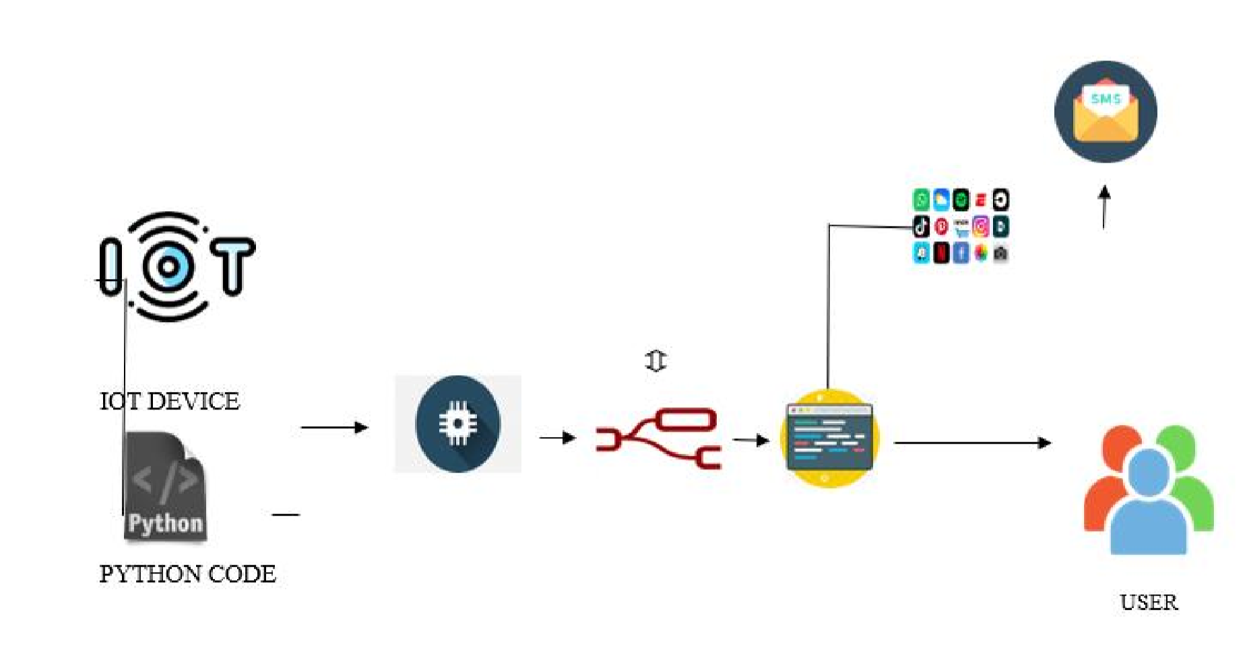

Feed the data received from the Sensor unit which are placed in the river sides.

1. The collected data will be displayed in the Web page to the user.
2. Then the collected data is sent to the data base, where the collected data and the predefined data are checked and monitored. If any data exceed the predefined data then the control signal will send to the Admin.
3. The collected data will be stored in the IBM cloud storage.
4. Later the data will be controlled by the admin via Web UI.

Components & Technologies:

|  |  |  |  |
| --- | --- | --- | --- |
| S.No | Component | Description | Technology |
| 1. | Received Data from  Sensors | The data collected form the sensor units placed in the river sides. | ESP32 Wifi module |
| 2. | Web Interface | The collected data were displayed visually. | HTML, CSS,  JavaScript |
| 3. | Database | Datatype | MySQL |
| 4. | Cloud Database | Database Service on  Cloud | IBM cloud |
| 5. | Data Storage | File storage requirements | IBM Block Storage |

Application Characteristics:

|  |  |  |  |
| --- | --- | --- | --- |
| S.No | Characteristics | Description | Technology |
| 1. | PH level Monitoring | The PH level of river water can be monitored via placing sensors in rivers. | PH-sensor |
| 2. | Temperature  Monitoring | The temperature of river water can be monitored | Temperature sensor |
| 3. | Pollution Monitoring | The clarity and purity of river water can be monitored | Conductive sensor |
| 4. | Soil level Monitoring | The amount of soil mixed in the river water can be measured | Turbidity sensor |